**MAJOR PROJECT SYNOPSIS**

**PROBLEM STATEMENT:**

Make An Flutter Application Adding Display Your name In The Center And Add ThreeButtons.One ButtonIntro,OneButton Education,One Button Skills.When You Press A Button, the Respective Page Should Load Using Navigation Pop MethodAnd Take You To New Screen And Display the Respective Details

**OBJECTIVE:**

* The user can navigate the screen as for requirement.

**ABSTRACT:**

This app allow the user to navigate the screen . The user can move from one screen to another screen by using push and pop navigator method.

# HARDWARE / SOFTWARE Requirements

**Software Requirements:**

**➢** IDE: Android Studio

➢ Operating System: Microsoft Windows/Linux

**Hardware Requirements:**

➢ Processor: Pentium-3 or Higher

➢ RAM: 64MB or Higher

➢ Hard Disk: 80GB or Higher

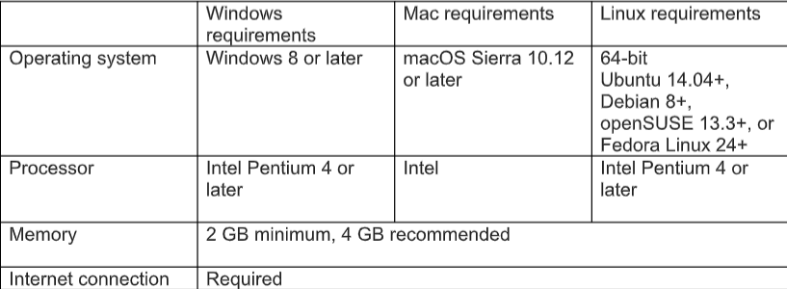

METHODLOGY:

CODE OF THE PROGRAM:

import 'package:flutter/cupertino.dart';

import 'package:flutter/material.dart';

void main() {

runApp(const MaterialApp(

title: 'Major project',

home: FirstPage(),

));

}

class FirstPage extends StatelessWidget {

const FirstPage({Key? key}) : super(key: key);

@override

Widget build(BuildContext context) {

return Scaffold(

appBar: AppBar(

title: const Text('MainPage'),

),

body: Center(

child: Column(

mainAxisAlignment: MainAxisAlignment.center,

children: <Widget>[

const Text('ADITHYA HOLLa K',

style: TextStyle(fontSize: 40, fontStyle: FontStyle.italic, color: Colors.indigoAccent)),

Row(

mainAxisAlignment: MainAxisAlignment.center,

children: [

Padding(

padding: EdgeInsets.all(16),

child: ElevatedButton(

child: const Text('Introduction'),

onPressed: () {

Navigator.push(

context,

MaterialPageRoute(

builder: (context) => const IntroductionPage()),

);

},

),

),

Padding(

padding: EdgeInsets.all(16),

child: ElevatedButton(

child: const Text('Education'),

onPressed: () {

Navigator.push(

context,

MaterialPageRoute(

builder: (context) => const EducationPage()),

);

},

),

),

Padding(

padding: EdgeInsets.all(16),

child: ElevatedButton(

child: const Text('Skills'),

onPressed: () {

Navigator.push(

context,

MaterialPageRoute(

builder: (context) => const SkillPage()),

);

},

),

),

],

)

],

)));

}

}

class IntroductionPage extends StatelessWidget {

const IntroductionPage({Key? key}) : super(key: key);

@override

Widget build(BuildContext context) {

return Scaffold(

appBar: AppBar(

title: const Text('IntroductionPage'),

),

body: Center(

child: Column(children: <Widget>[

const Text(

" I am ADITHYA HOLLA K . We are 10 members in my family including me. I am native to Kundapur. Currently , I am purusing 3rd year at NMAMIT and my graduation is about to complete in next couple of years.My strengths are my analytical approach, my appreciable communication,and presentation skills. I believe in being realistic. ",

style: TextStyle(fontSize: 18, fontStyle: FontStyle.normal)),

Padding(

padding: EdgeInsets.all(280),

child: ElevatedButton(

onPressed: () {

Navigator.pop(context);

// //

},

child: const Text('Go back!'),

),

),

])));

}

}

class EducationPage extends StatelessWidget {

const EducationPage({Key? key}) : super(key: key);

@override

Widget build(BuildContext context) {

return Scaffold(

appBar: AppBar(

title: const Text('Education Page'),

),

body: Center(

child:

Column( children: <

Widget>[

const Text(

' As I compled my sslc in Sri Venkataramana English Medium school which is held in kundapur. I completed my sslc in 2017 by scoring 96%. I completed my puc in Excellent Pu College which was held in Sunnari . I passout in 2019 by scoring 95% . I took Biology as my subject in puc. I joined NMAMIT nitte in 2019 by taking Computer Science Engineering .'

'Now I am pursing 3rd year. I score 9.34 as Sgpa in my fifth sem.',

style: TextStyle(fontSize: 22, fontStyle: FontStyle.normal)),

Center(

child: Column(children: <Widget>[

Container(

margin: EdgeInsets.all(20),

child: Table(

defaultColumnWidth: FixedColumnWidth(120.0),

border: TableBorder.all(

color: Colors.black, style: BorderStyle.solid, width: 2),

children: [

TableRow(children: [

Column(children: [

Text('Course/Degree', style: TextStyle(fontSize: 20.0))

]),

Column(children: [

Text('Name of school and college',

style: TextStyle(fontSize: 20.0))

]),

Column(children: [

Text('Grade obtained', style: TextStyle(fontSize: 20.0))

]),

Column(children: [

Text('Year of a passing',

style: TextStyle(fontSize: 20.0))

]),

]),

TableRow(children: [

Column(children: [Text('3rd year BE')]),

Column(children: [Text('NMAMIT , Nitte')]),

Column(children: [Text('8.8')]),

Column(children: [Text('pursuing')]),

]),

TableRow(children: [

Column(children: [Text('Pre University')]),

Column(children: [Text('Excellent Pu College ,Sunnari')]),

Column(children: [Text('95%')]),

Column(children: [Text('2019')]),

]),

TableRow(children: [

Column(children: [Text('SSLC')]),

Column(children: [

Text('Sri Venkataramana English Medium School , Kundapur')

]),

Column(children: [Text('96%')]),

Column(children: [Text('2017')]),

]),

],

),

),

])),

Padding(

padding: EdgeInsets.all(100),

child: ElevatedButton(

onPressed: () {

Navigator.pop(context);

// //

},

child: const Text('Go back!'),

),

),

])));

}

}

class SkillPage extends StatelessWidget {

const SkillPage({Key? key}) : super(key: key);

@override

Widget build(BuildContext context) {

return Scaffold(

appBar: AppBar(

title: const Text('Skill Page'),

),

body: Center(

child: Column(children: <Widget>[

const Text(' I have skills like:''Leadership experience ,Communication skills ,Organizational skills ,'Time management , Computer profiency, Problem Solving skills,'Team work and collaboration,'Criticalthinking,Interpersonal skills,Working well.',

style: TextStyle(fontSize: 20, fontStyle: FontStyle.normal)),

Padding(

padding: EdgeInsets.all(285),

child: ElevatedButton(

onPressed: () {

Navigator.pop(context);

// //

},

child: const Text('Go back!'),

),

),

])));

}

}

**Screenshort of the code:**

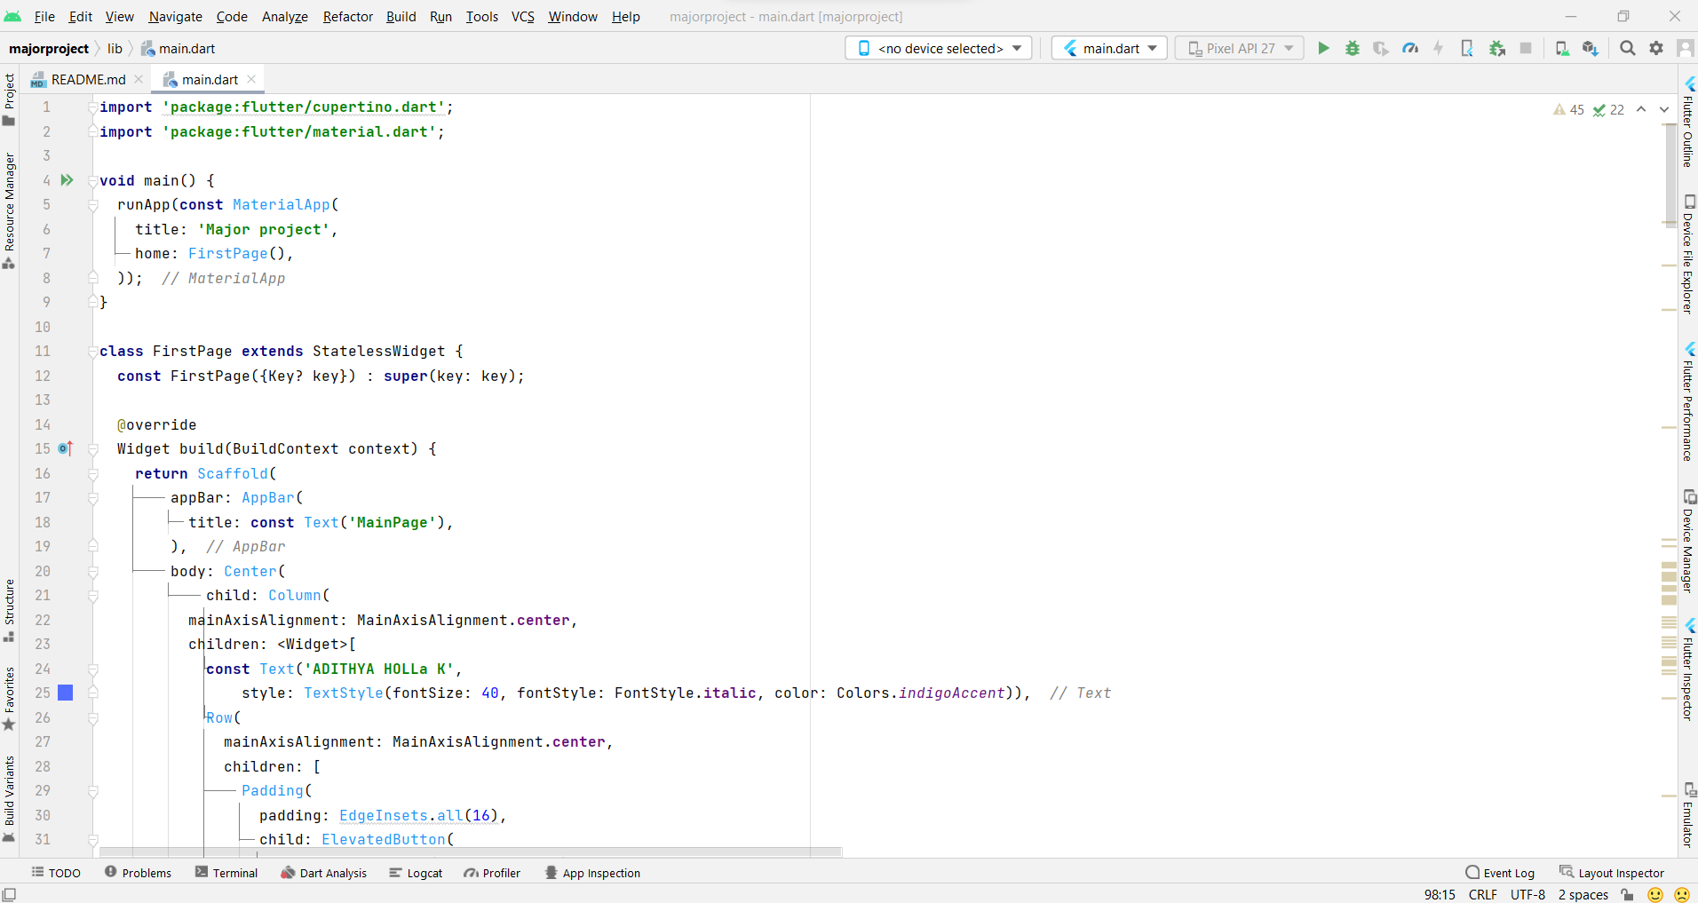

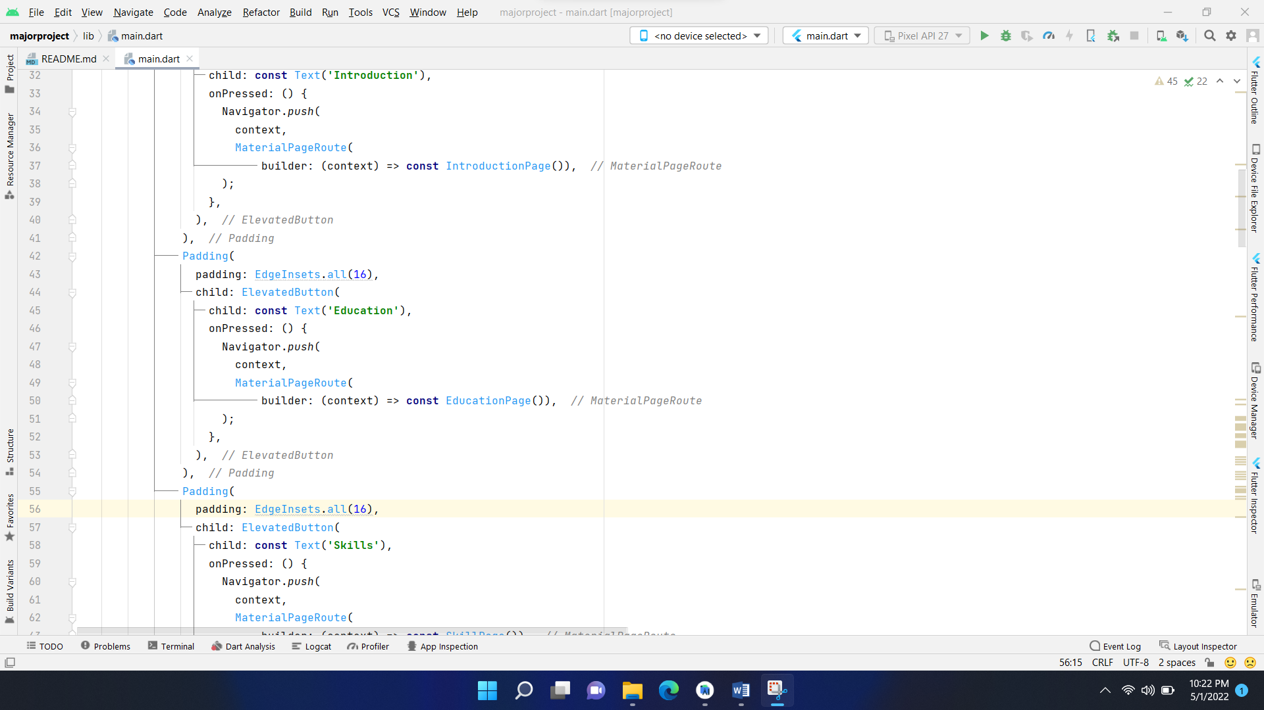

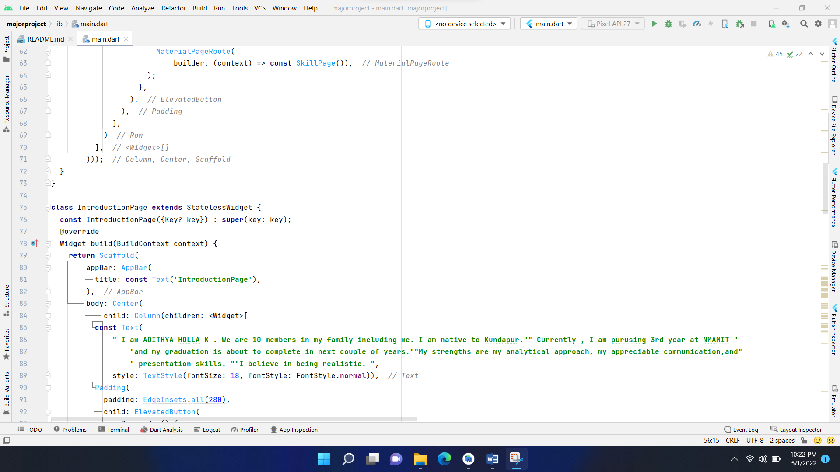

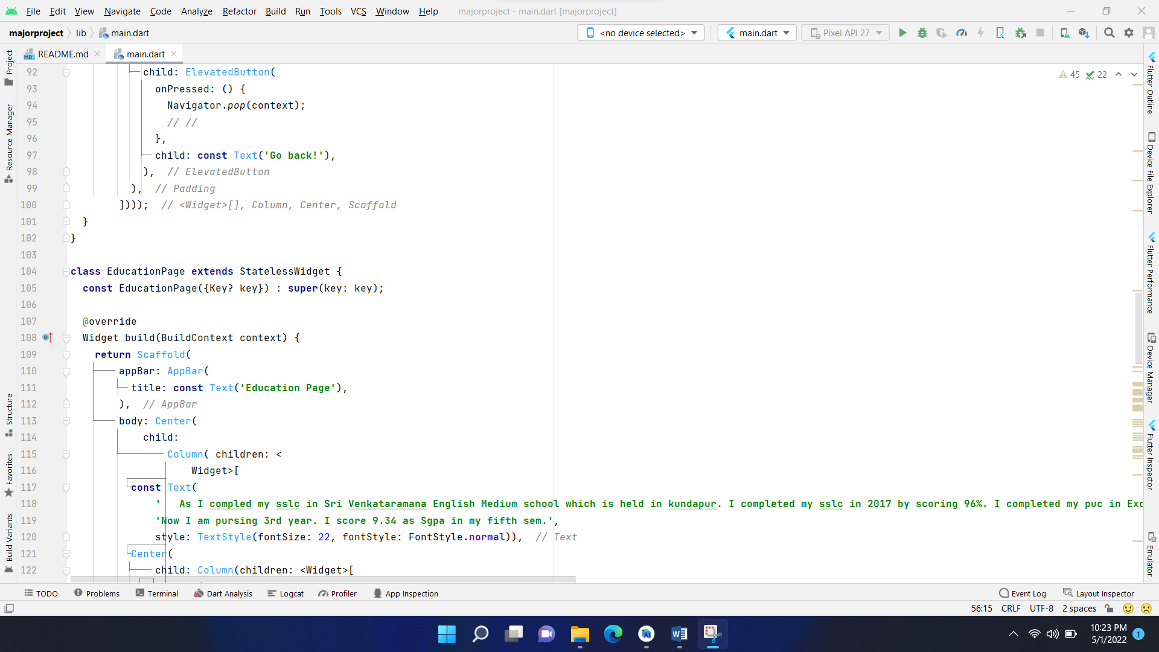

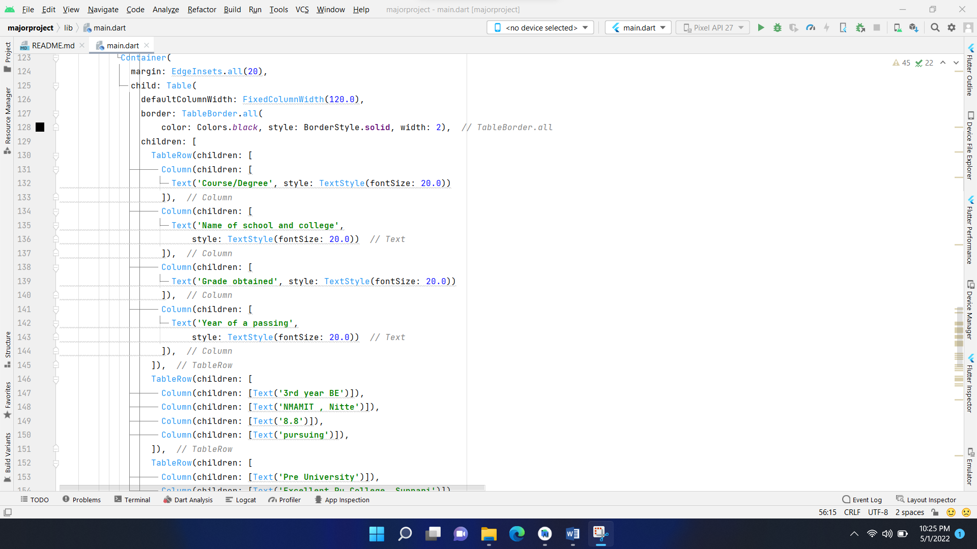

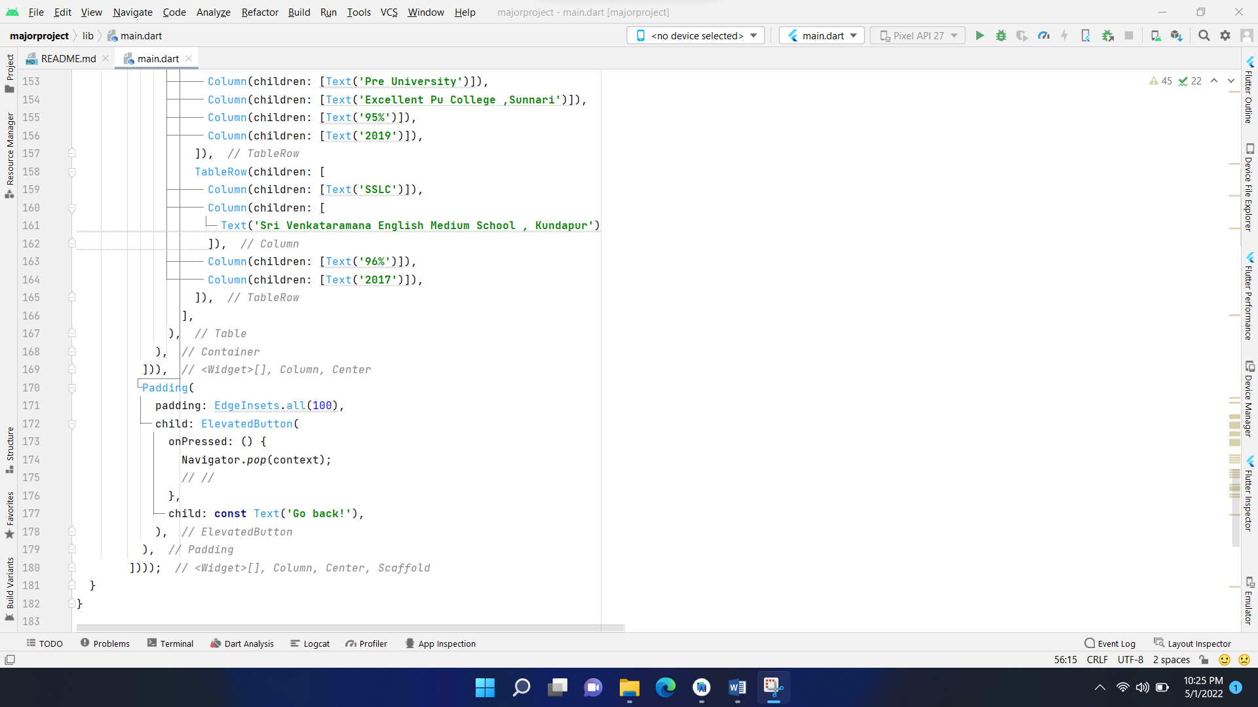

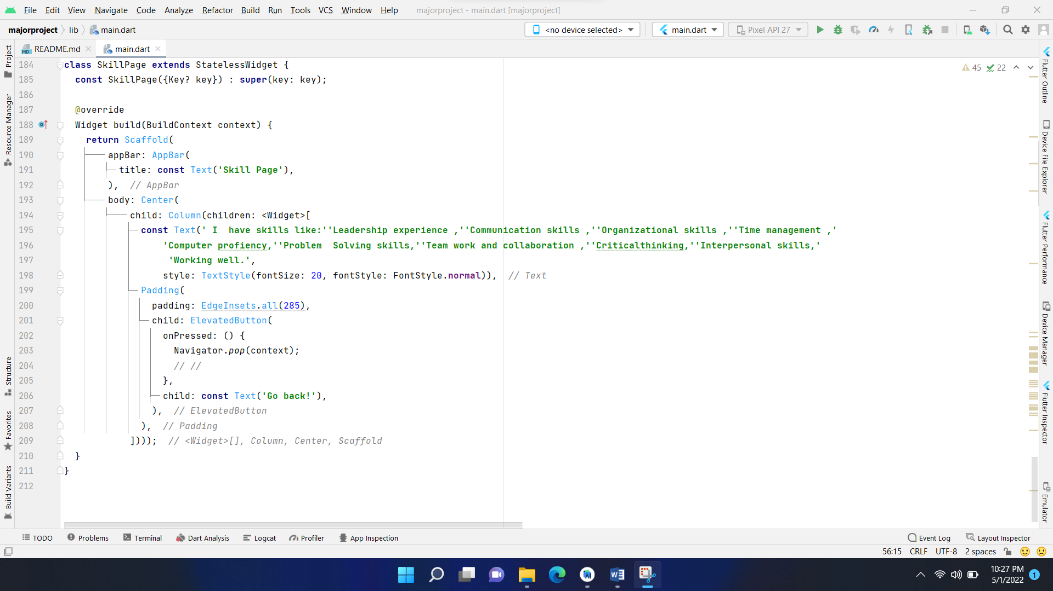

import 'package:flutter/cupertino.dart';  
import 'package:flutter/material.dart';  
  
void main() {  
 runApp(const MaterialApp(  
 title: 'Major project',  
 home: FirstPage(),  
 ));  
}  
  
class FirstPage extends StatelessWidget {  
 const FirstPage({Key? key}) : super(key: key);  
  
 @override  
 Widget build(BuildContext context) {  
 return Scaffold(  
 appBar: AppBar(  
 title: const Text('MainPage'),  
 ),  
 body: Center(  
 child: Column(  
 mainAxisAlignment: MainAxisAlignment.center,  
 children: <Widget>[  
 const Text('ADITHYA HOLLa K',  
 style: TextStyle(fontSize: 40, fontStyle: FontStyle.italic, color: Colors.*indigoAccent*)),  
 Row(  
 mainAxisAlignment: MainAxisAlignment.center,  
 children: [  
 Padding(  
 padding: EdgeInsets.all(16),  
 child: ElevatedButton(  
 child: const Text('Introduction'),  
 onPressed: () {  
 Navigator.*push*(  
 context,  
 MaterialPageRoute(  
 builder: (context) => const IntroductionPage()),  
 );  
 },  
 ),  
 ),  
 Padding(  
 padding: EdgeInsets.all(16),  
 child: ElevatedButton(  
 child: const Text('Education'),  
 onPressed: () {  
 Navigator.*push*(  
 context,  
 MaterialPageRoute(  
 builder: (context) => const EducationPage()),  
 );  
 },  
 ),  
 ),  
 Padding(  
 padding: EdgeInsets.all(16),  
 child: ElevatedButton(  
 child: const Text('Skills'),  
 onPressed: () {  
 Navigator.*push*(  
 context,  
 MaterialPageRoute(  
 builder: (context) => const SkillPage()),  
 );  
 },  
 ),  
 ),  
 ],  
 )  
 ],  
 )));  
 }  
}  
  
class IntroductionPage extends StatelessWidget {  
 const IntroductionPage({Key? key}) : super(key: key);  
 @override  
 Widget build(BuildContext context) {  
 return Scaffold(  
 appBar: AppBar(  
 title: const Text('IntroductionPage'),  
 ),  
 body: Center(  
 child: Column(children: <Widget>[  
 const Text(  
 ‘ I am ADITHYA HOLLA K . We are 10 members in my family including me. I am native to Kundapur. Currently , I am purusing 3rd year at NMAMIT and my graduation is about to complete in next couple of years. My strengths are my analytical approach, my appreciable communication, presentation skills. ""I believe in being realistic. ‘,  
 style: TextStyle(fontSize: 18, fontStyle: FontStyle.normal)),  
 Padding(  
 padding: EdgeInsets.all(280),  
 child: ElevatedButton(  
 onPressed: () {  
 Navigator.*pop*(context);  
 *// //* },  
 child: const Text('Go back!'),  
 ),  
 ),  
 ])));  
 }  
}  
  
class EducationPage extends StatelessWidget {  
 const EducationPage({Key? key}) : super(key: key);  
  
 @override  
 Widget build(BuildContext context) {  
 return Scaffold(  
 appBar: AppBar(  
 title: const Text('Education Page'),  
 ),  
 body: Center(  
 child:  
 Column( children: <  
 Widget>[  
 const Text(  
 ' As I compled my sslc in Sri Venkataramana English Medium school which is held in kundapur. I completed my sslc in 2017 by scoring 96%. I completed my puc in Excellent Pu College which was held in Sunnari . I passout in 2019 by scoring 95% . I took Biology as my subject in puc. I joined NMAMIT nitte in 2019 by taking Computer Science Engineering .'  
 'Now I am pursing 3rd year. I score 9.34 as Sgpa in my fifth sem.',  
 style: TextStyle(fontSize: 22, fontStyle: FontStyle.normal)),  
 Center(  
 child: Column(children: <Widget>[  
 Container(  
 margin: EdgeInsets.all(20),  
 child: Table(  
 defaultColumnWidth: FixedColumnWidth(120.0),  
 border: TableBorder.all(  
 color: Colors.*black*, style: BorderStyle.solid, width: 2),  
 children: [  
 TableRow(children: [  
 Column(children: [  
 Text('Course/Degree', style: TextStyle(fontSize: 20.0))  
 ]),  
 Column(children: [  
 Text('Name of school and college',  
 style: TextStyle(fontSize: 20.0))  
 ]),  
 Column(children: [  
 Text('Grade obtained', style: TextStyle(fontSize: 20.0))  
 ]),  
 Column(children: [  
 Text('Year of a passing',  
 style: TextStyle(fontSize: 20.0))  
 ]),  
 ]),  
 TableRow(children: [  
 Column(children: [Text('3rd year BE')]),  
 Column(children: [Text('NMAMIT , Nitte')]),  
 Column(children: [Text('8.8')]),  
 Column(children: [Text('pursuing')]),  
 ]),  
 TableRow(children: [  
 Column(children: [Text('Pre University')]),  
 Column(children: [Text('Excellent Pu College ,Sunnari')]),  
 Column(children: [Text('95%')]),  
 Column(children: [Text('2019')]),  
 ]),  
 TableRow(children: [  
 Column(children: [Text('SSLC')]),  
 Column(children: [  
 Text('Sri Venkataramana English Medium School , Kundapur')  
 ]),  
 Column(children: [Text('96%')]),  
 Column(children: [Text('2017')]),  
 ]),  
 ],  
 ),  
 ),  
 ])),  
 Padding(  
 padding: EdgeInsets.all(100),  
 child: ElevatedButton(  
 onPressed: () {  
 Navigator.*pop*(context);  
 *// //* },  
 child: const Text('Go back!'),  
 ),  
 ),  
 ])));  
 }  
}  
  
class SkillPage extends StatelessWidget {  
 const SkillPage({Key? key}) : super(key: key);  
  
 @override  
 Widget build(BuildContext context) {  
 return Scaffold(  
 appBar: AppBar(  
 title: const Text('Skill Page'),  
 ),  
 body: Center(  
 child: Column(children: <Widget>[  
 const Text(' I have skills like:'Leadership experience ,''Communication skills ,''Organizational skills ,''Time management , 'Computer profiency,''Problem Solving skills,''Team work and collaboration ,'Criticalthinking,'Interpersonal skills,'Working well.',  
 style: TextStyle(fontSize: 20, fontStyle: FontStyle.normal)),

Padding(  
 padding: EdgeInsets.all(285),  
 child: ElevatedButton(  
 onPressed: () {  
 Navigator.*pop*(context);  
 *// //* },  
 child: const Text('Go back!'),  
 ),  
 ),  
 ])));  
 }  
}

**OUTPUT SCREEN RESULT:**

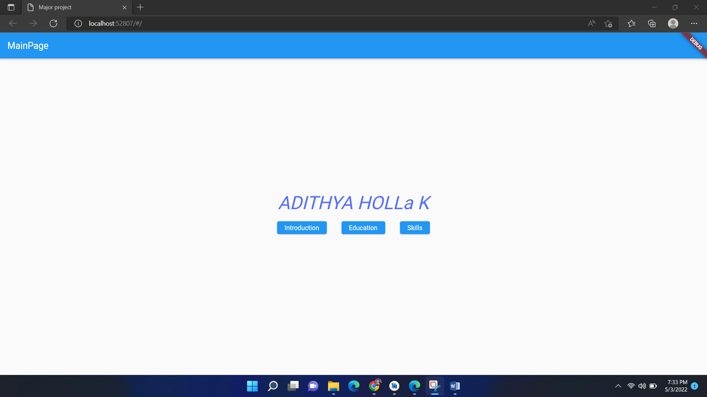

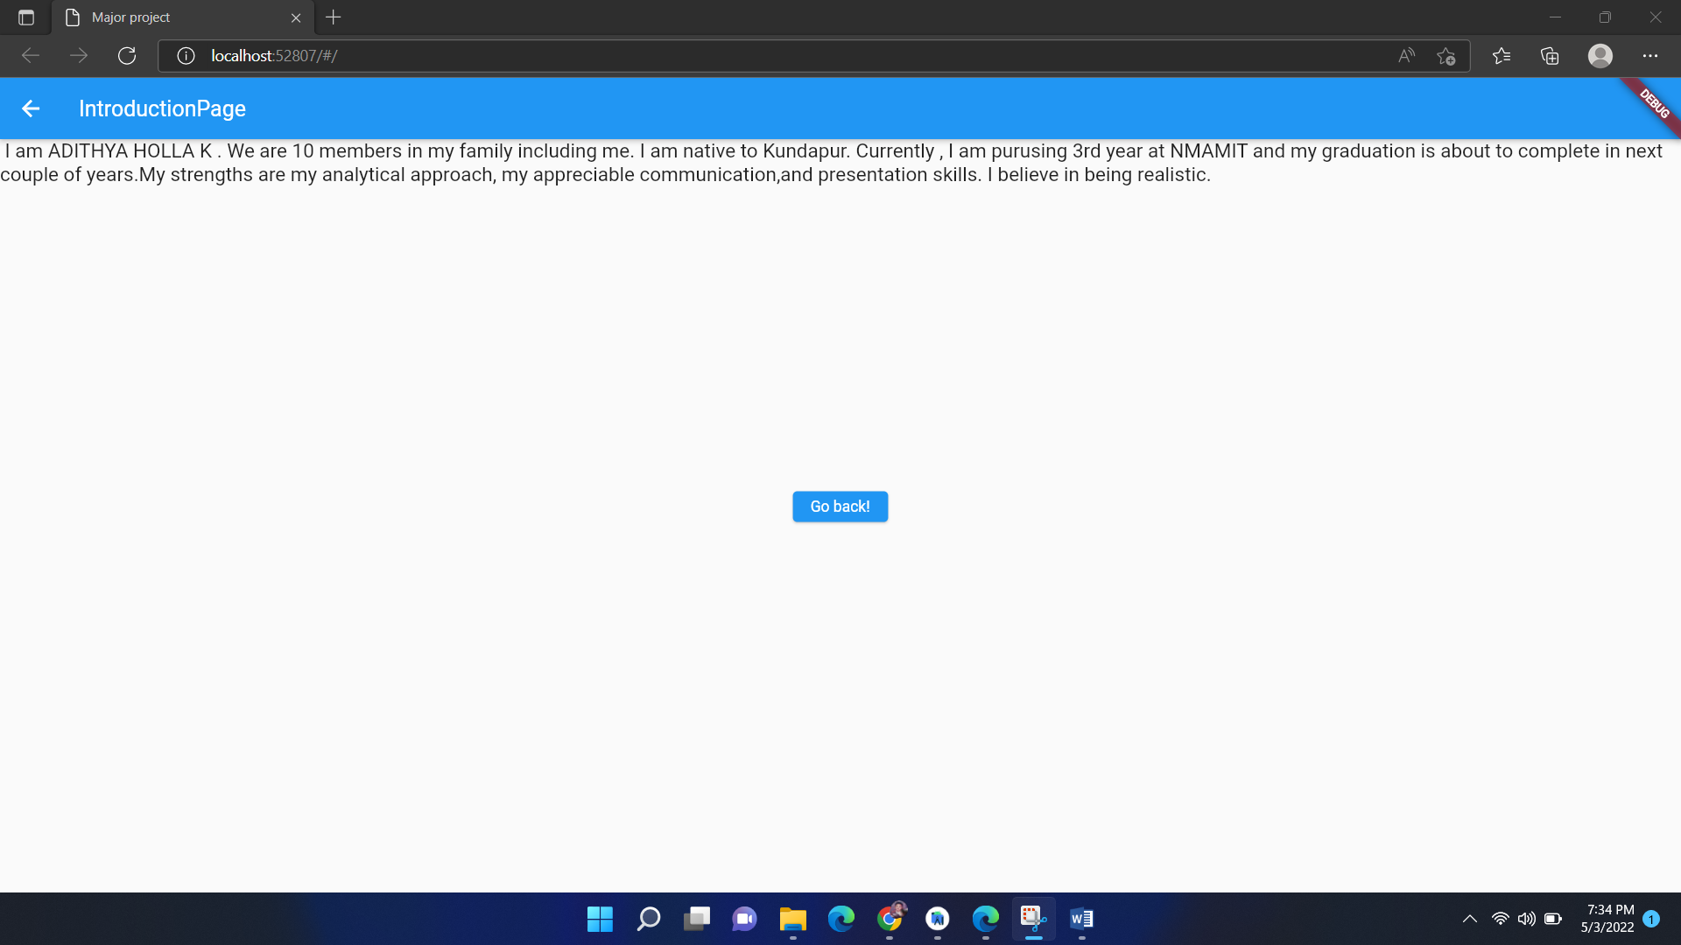

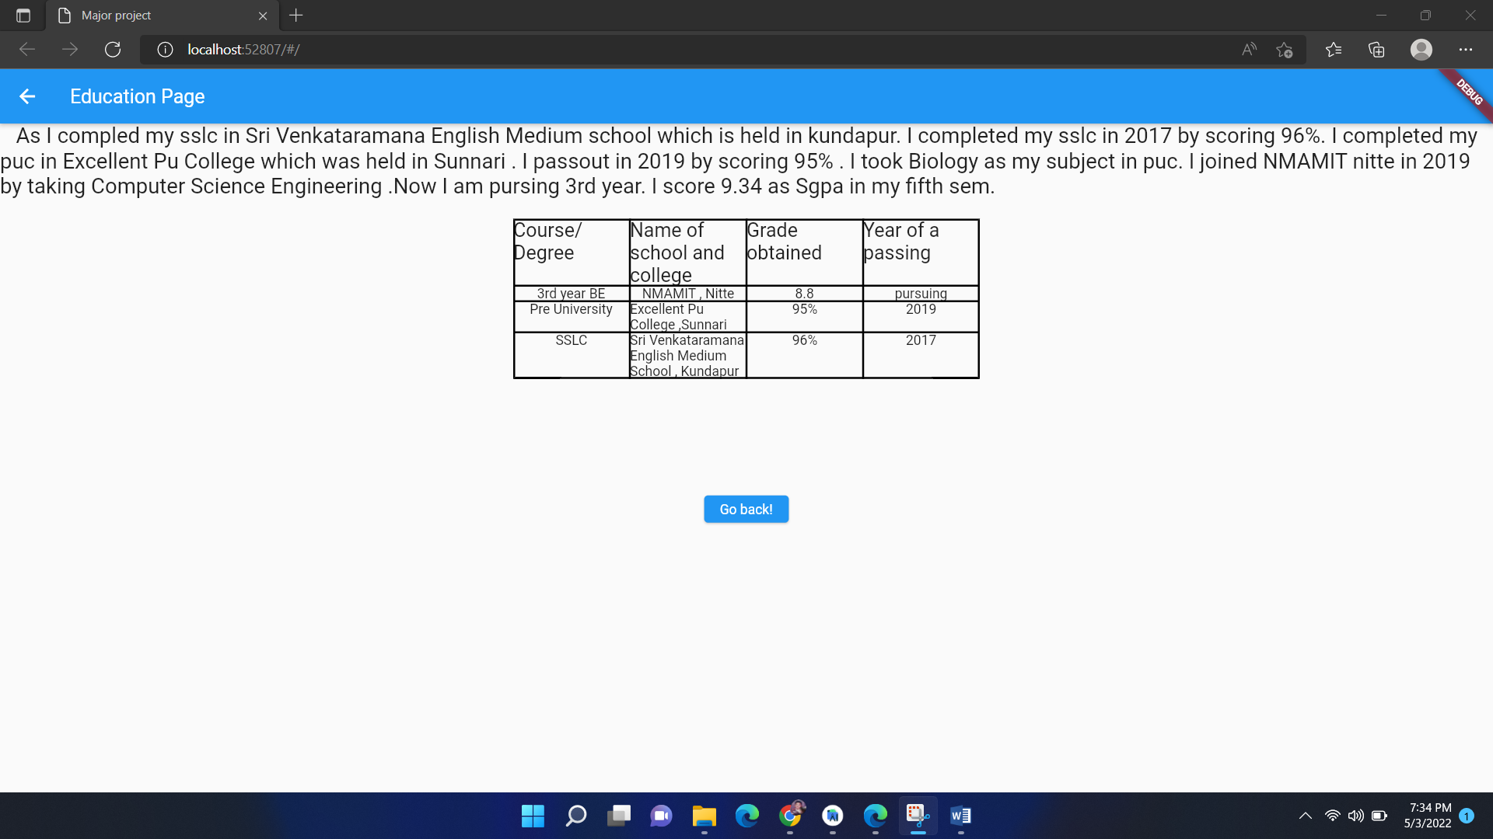

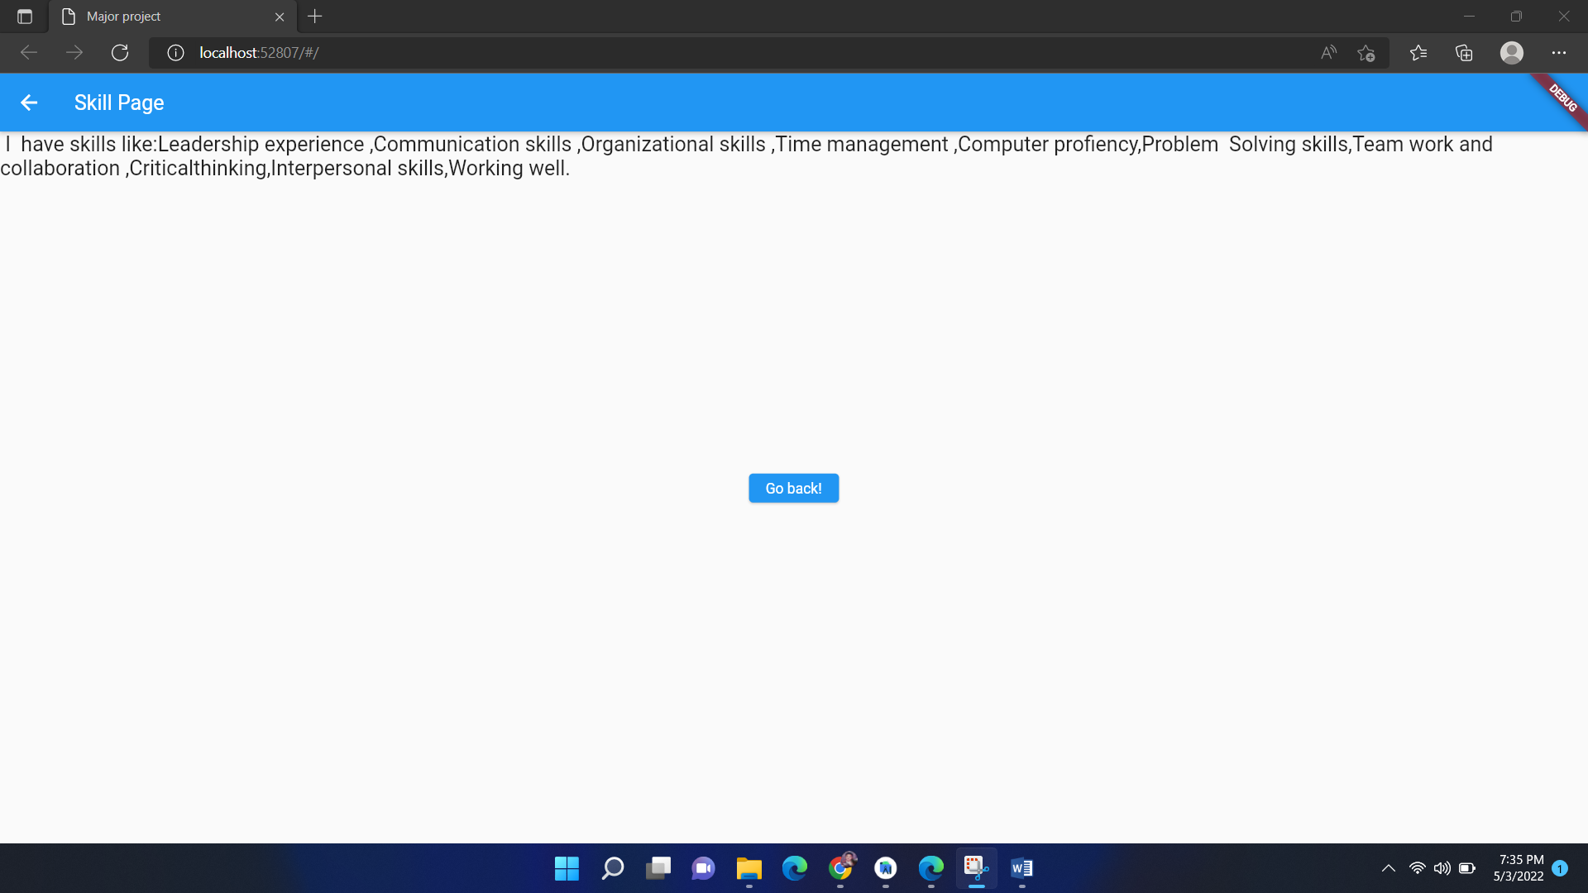

**DESCRIPTION OF OUTPUT SCREEN:**

This is the main page of the project where the name is at center . this page is consist of 3 button namely introduction , Education , skill button. In this page by using the button the user can click any button and it load it respective page also the user can return to the main page. The user can go to respective page by using navigator push option.



This is the introduction page where the user navigate from the main page to this page by using navigator push option , where the user clicked on the introduction button , as soon as the user clicked this button the page navigate to the introduction page. The user also can come to main page by clicking go back button .this return to main page.



This is the Education page where the user navigate from the main page to this page by using navigator push option , where the user clicked on the Education button , as soon as the user clicked this button the page navigate to the Education page. The user also can come to main page by clicking go back button .this return to main page.



This is the Skill page where the user navigate from the main page to this page by using navigator push option , where the user clicked on the Skill button , as soon as the user clicked this button the page navigate to the Skill page. The user also can come to main page by clicking go back button .this return to main page

